1. Sign your name in black ink on a clean, blank sheet of paper. Sign in the middle of the paper so you don't photograph or scan the edges.
2. Photograph or scan your signature. If you are taking a picture of your signature, make sure the page is well lit and that no shadows fall across the signature.
3. Transfer the photo or scan to your computer. Reader accepts JPG, PNG, GIF, and BMP files. Keep track of its location so you can find it when signing PDFs. You do not need to crop the image. Reader imports just the signature.
- Open the PDF you want to sign.
- Click the Sign icon in the toolbar to open the Sign pane.
If the Sign icon is not in the toolbar, right-click the toolbar, and choose File> Add Text or Signature.
- In the Sign pane, click Place Signature.
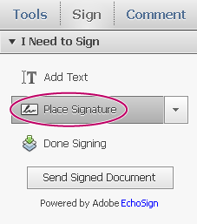
The first time you sign, the Place Signature option opens a dialog box to allow you to create or import your signature.
- (First time signing) In the Place Signature dialog box, choose how you want to place your signature:
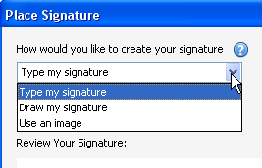
Use an image
Click Browse, and locate your signature file. When your signature appears in the dialog box, click Accept.
- Click in the PDF where you want to place your signature.
- Move, resize, or rotate the signature
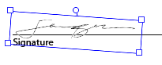
- When the document is complete, click Done Signing in the Sign pane.
- When prompted, “Any signatures or added text will now be permanently merged into the PDF...”, click Confirm.
- Specify the location for the file, and click Save.

